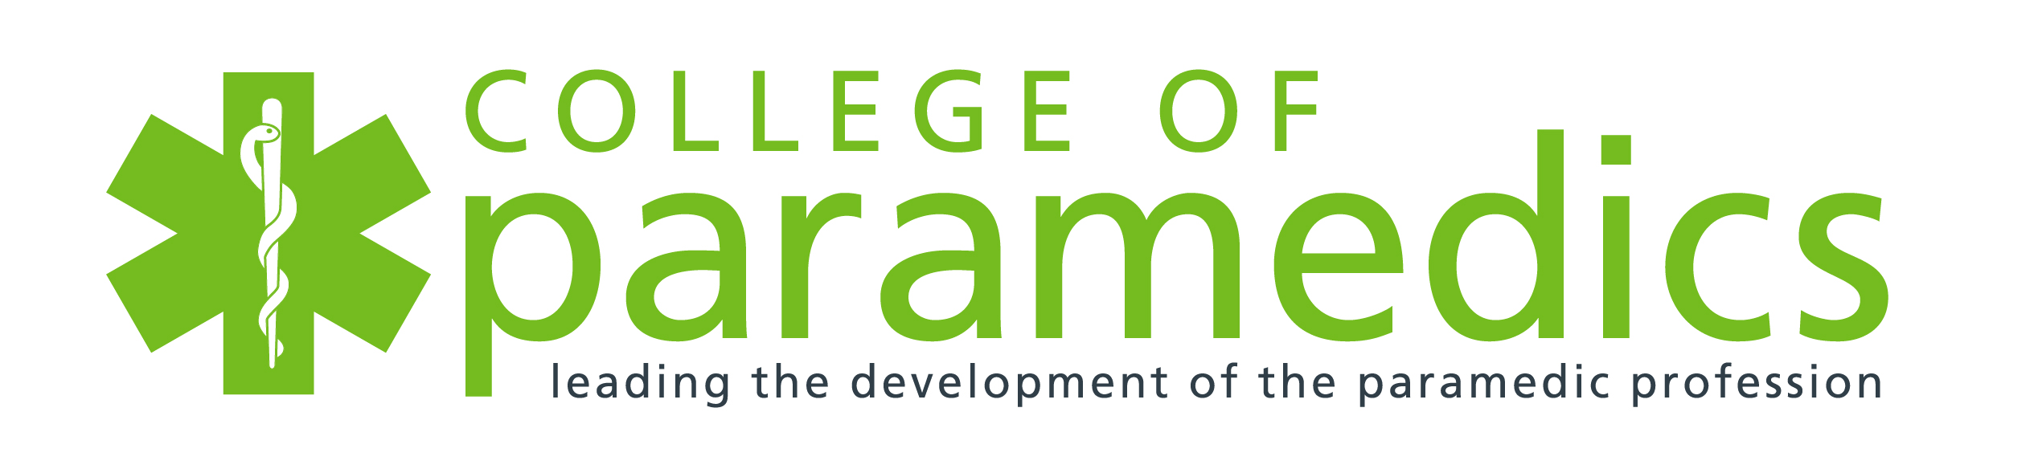
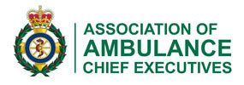

Certificate of Attendance

This is to certify that

………………..

Attended the

Webinar

Uncomfortable Conversations:
Exploring Disability Culture

5th May 2022

John Martin

President, College of Paramedics

This certificate denotes the attendance at an event organised with the College of Paramedics only. It does not signify membership of the Professional Body or the individuals’ competency or ability to practice. All paramedics in the UK must be registered with the Health and Care Professions Council. For further details visit the HCPC website – www.hcpc-uk.org

