Reducing misogyny and improving
sexual safety in the ambulance service

Next steps

October 2023

Contents

Next steps 2

Recommendations 5
Recommendation 1: Accountability and leadership 5
Recommendation 2: Confidential reporting and support 6
Recommendation 3: Commitment to learning 6
Recommendation 4: Culture transformation 6

The Sexual Safety in Healthcare Organisations Charter 7

Appendix 1. Project stakeholders. 8

Useful references and resources 9

Acknowledgements. Thank you for the following people involved in the development of the ‘Next Steps’ document. 11

Next steps

This document sets out the recommendations for action to reduce misogyny and improve sexual safety in the Ambulance Service. It takes forward the commitments made in the ‘Reducing Misogyny & Improving Sexual Safety in the Ambulance Service: Consensus Statement 2023’, which are based on our findings from reviewing the available evidence and engaging with stakeholders.

The recommendations:
- are evidence based and aim to instigate more consistency throughout the sector
- are not a replacement for any criminal proceedings or specialist safeguarding advice
- may overlap with support for colleagues experiencing domestic abuse and local policies (eg relationships at work)
- should pre-empt scenarios of ‘perpetrator and victim’ in the same workplace.

The ‘Reducing misogyny and improving sexual safety in the ambulance service: Consensus statement 2023’ highlights that misogyny and any form of sexual misconduct in the ambulance service can be perpetrated in the following structures:
- Colleague towards colleague*.
The most prevalent based on what we know, and where the interventions outlined within this document are focused.

- Colleague towards patient.
Anyone abusing their position within the ambulance service will be subject to disciplinary procedures. Professional registrants are required to align to relevant codes of standards, conduct and ethics.

- Patient towards colleague.
Each trust should have a specific reporting process in place and accessible support for affected colleagues*

*We define colleagues as anyone working the ambulance sector including those returning to practice, students, and apprentices
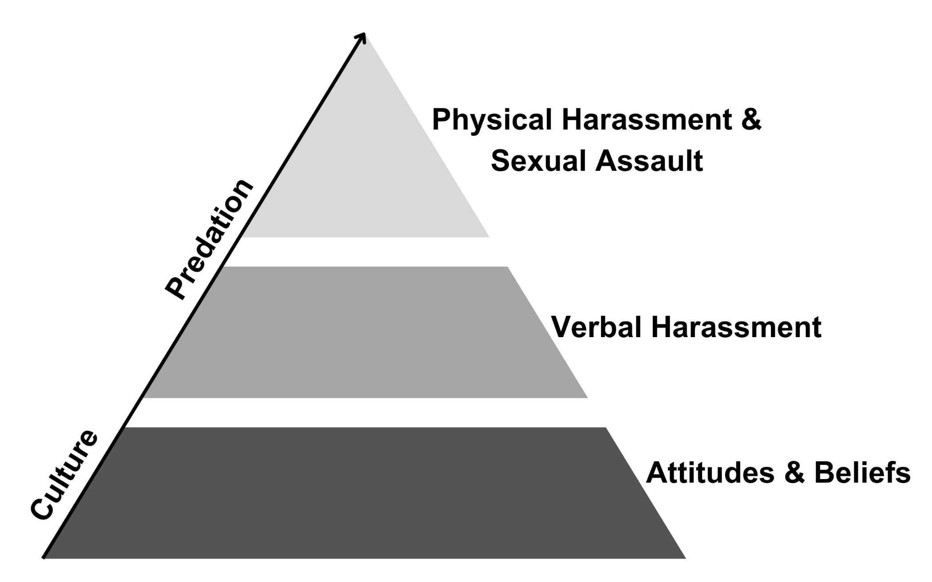
Figure 1: Misogyny and sexual safety pyramid

Recommendations

To enable positive change and build on measures already in place, the following recommendations are made.

Recommendation 1: Accountability and leadership

Every trust has a legal responsibility and duty of care to protect everyone working within the ambulance service from harm. Acknowledging the problem of misogyny and sexual misconduct in the ambulance service, with full ownership is a leadership foundation to build upon.
Approaching the subject with a willingness to address own bias, an openness to listen to lived experience, recognise, and remove systemic barriers to speaking up, engage with reflective practice and communicate with full transparency seek to build psychological safety.
Measures for implementation:
- Regular climate surveys
- Support and advocacy of employee led networks.
- Continual listening of colleague experience data
- Improvement review of current measures
- Engage with reverse mentoring with those with lived and learned experiences.
- Socialise personal journey of reflection to role model the learning approach to change.
- Commitment to misogyny and sexual safety remaining a priority.

The Paramedic leadership document draws attention to cultural themes of misogyny and sexual safety.

Recommendation 2: Confidential reporting and support

Individuals will be supported to safely report all concerns of a sexual or misogynistic nature with the option within any process or policy to include a ‘bypass’ to allow initial concerns to be shared with someone away from the Line Management structure.
Reporting routes and wellbeing support should be accessible, confidential, and communicated regularly.

The creation of safe and inclusive spaces to empower individual choice.

It may be appropriate to refer complex cases (including non-recent experiences) to an independent adviser to ensure a victim centred approach is taken.

Recommendation 3: Commitment to learning

Organisational and individual learning, at every level is required for effective intervention.

The development of a learning module to be developed and each trust/ health board to identify colleagues to facilitate delivery.

To encourage broader awareness raising, collaborative educational events to cover a range of subjects [eg, men’s (and those who identify as male) mental health, allyship, the active bystander and student experiences].

Support for line managers with identifying and acting upon ‘problem’ patterns of behaviour.

Access to specialist perpetrator behaviour change support.

Recommendation 4: Culture transformation

Focusing on prevention, the correlation between cultural norms and predation (Figure 1) should align to any broader transformational workstreams.
Increased diversity reduces the risk of sexual misconduct (which does not occur in isolation) and improving inclusion should remain a strategic direction for each Trust.

Review approach to risk management of concerns (victim centred approach) and improve consistency of employee relations advice.
Continued sharing of learning and best practice throughout the sector.
Evaluating the impact of trust level measures and interventions with the input of lived experience. See an example self-audit tool.

The Sexual Safety in Healthcare Organisations Charter

For those working in the Ambulance service in England both the Association of Ambulance Chief Executives and NHS England have signed up to the Sexual Safety in Healthcare Organisational Charter. This represents the key framework for health and care systems to ensure the sexual safety of all staff. Following publication in September 2023, work is ongoing to implement this charter and individual ambulance Trusts are encouraged to sign-up.

Appendix 1. Project stakeholders.
NHS England  - Office of the Chief Allied Health Professions Officer (CAHPO)  - Workforce Training, and Education Directorate (WTE)  - Urgent and Emergency Care (UEC)  - Intensive Support team  - Communications  - Domestic Abuse and Sexual Violence (DASV) team  Office of Health Inequalities and Disparities (OHID)  College of Paramedics (including the student committee)  The Ambulance Staff Charity (TASC)  Social Partnership Forum  NHS Employers  Chief AHP Advisors  - Scotland  - Northern Ireland  - Wales | Association of the Ambulance Chief Executives (AACE)  - Council  - Ambulance Trust HR Directors (HRDs)  - National Directors of Operations Group (NDOG)  - Women’s Network  - National Ambulance Diversity and Inclusion Forum (NADIF)  Ambulance Trusts  - England including the Isle of Wight  - Wales  - Scotland  - Northern Ireland  - Wellbeing guardians  - “Freedom to Speak Up” Guardian network.  National Guardians Office  Researchers working in related field.  Individuals with lived experience in the Ambulance service
Reducing misogyny and improving sexual safety in the ambulance service

Useful references and resources

- Association of Ambulance Chief Executives (AACE, 2021a) Clinical Supervision a Framework for UK Ambulance Services. Retrieved, 31 March 2023.
- Association of Ambulance Chief Executives (AACE, 2021b) Uncomfortable Conversations: Abuse of position of trust. Retrieved, 20 June 2022.
- Association of Ambulance Chief Executives (AACE, 2021c) Working together to prevent suicide in the Ambulance Service. Retrieved, 15 May 2022.
- Ambulance Victoria (2022). Independent Review of Ambulance Victoria. Retrieved, 20 May 2022.
- Care Quality Commission (CQC, 2010) Learning webinar: Sexual safety in the Ambulance services. Retrieved, 10 June 2022.
- College of Paramedics (2021) Sexual Harassment and Inappropriate Behaviour Webinar Series. Retrieved, 20 May 2023.
- Equality Act 2010
- General Medical Council (GMC, 2022) No place for sexual misconduct in UK healthcare. Retrieved, 12 July 2022.
- General Medical Council (GMC, nd) Respect protects - tools to help you tackle unprofessional behaviour. Retrieved, 12 July 2002.
- Health and Care Professions Council (HCPC, 2016). Standards of conduct performance and ethics. Retrieved, 25 May 2022.
*Please note updated standards are being drafted
- Health and Care Professionals Council (HCPC, 2023) Paramedics Standards of Proficiency. Retrieved, 02 September 2023.
- Health Education England. (2022). The National Education and Training Survey (NETS). Retrieved, 31 July 2023.
- The Metropolitan Police (2022) The Baroness Casey Review. Retrieved, 01 June 2023.
- National Guardian Office (NGO, 2023) Welcome to the National Guardian's Office: Making Speaking Up Business as Usual. Retrieved, 03 June 2023.
- National Guardian Office (NGO, 2023) Speak Up Review of Ambulance Trusts in England. Retrieved, 04 April 2023.
- NHS England (NHSE, 2023) Sexual Safety in Healthcare Organisational Charter. Retrieved, 19 September 2023
- NHS England. (NHSE, 2023). Equality, Diversity, and Inclusion Improvement Plan. Retrieved 10 July 2023.
- NHS England (NHSE, 2023). Paramedic leadership in ambulance trusts in England: Understanding the synergies and differences with other allied health professions’ leadership and leadership development. Retrieved, 04 July 2023.
- NHS England (NHSE, 2022). The AHP Strategy for England (2022-2027): AHPs Deliver. Retrieved, 03 January 2022.
- NHS England and NHS Improvement (NHSE & I, 2021) We are the NHS: People Plan for 2020/2021 - action for us all. Retrieved, 16 December 2022.
- NHS England (NHSE, 2019). The Long-Term Plan. London: England. Retrieved, 20 April 2022.
- NHS England (NHSE, 2019). Clinical leadership - a framework for action A guide for senior leaders on developing professional diversity at board level. Retrieved 31 Jul 2023.
- NHS England (NHSE, 2018) Lord Carter’s review into unwarranted variation in NHS ambulance trusts. Retrieved, 25 May 2022.
- Professional Standards Authority (PSA, 2019) Sexual Misconduct in Health and Social care: Understanding Types Of Abuse And Perpetrators’ Moral Mindsets. Retrieved, 04 July 2022.
- Public Health Scotland (2019) Gender based violence, Domestic abuse - What health workers need to know. Retrieved. 05 July 2023.
- Public Sector Equity Duties (2012)
- Nursing and Midwifery Council (NMC, 2018) Standards of proficiency for registered nurses. Retrieved, 06 June 2023.
- Royal College of Genealogists and Obstetrics (RCoG, 2021) Improving workplace behaviours. Retrieved, 03 June 2022.
- The Ambulance Service Charity (TASC, 2023) About TASC: What we Do. Retrieved, 03 May 2023.
- Surviving in Scrubs (2023) We Are Surviving in Scrubs. Retrieved, 03 November 2022.
- UK Parliament (2021). Protecting those who protect us: Women in the armed forces from recruitment to civilian life. The Atherton Report. Retrieved 05 June 2022.

Acknowledgements. Thank you for the following people involved in the development of the ‘Next Steps’ document.
Senior Responsible Officer | Professor Suzanne Rastrick OBE, (Senior Responsible Officer), Chief Allied Health Professions Officer (CAHPO, England), NHS England
Lead author | Bron Biddle, Organisational Development Manager, Welsh Ambulance Services NHS Trust (WAST) and Founder of Ambulance Voices
Special Acknowledgement | Dr Janice St. John-Matthews, Head of Allied Health Professionals, Office of the Chief AHP Officer (CAHPO), NHS England
 | Charlotte Hill, Senior Programme Manager, Urgent and Emergency Care (UEC), NHS England
Contributors
Ali Mohammad Human Resources Director,  Southeast Coast Ambulance NHS Trust (SCAS)  Anna Parry, Deputy Managing Director,  Association of Ambulance Chief Executives (AACE)  Caroline Waterfield, Director of Development & Employment, NHS Employers  Dr Catherine Goodwin, Consultant Clinical Psychologist, Assistant Direct Inclusion, Culture & Wellbeing Welsh Ambulance Services NHS Trust (WAST)  Catherine Hinwood OBE, NHS England Lead, Domestic Abuse and Sexual Violence, Deputy Director, Health, and Justice Team.  Carmen Peters, Freedom to Speak Up Guardian  Co-Chair - Freedom to Speak Up National Ambulance Network (NAN), London Ambulance Trust (LAS)  Coralie Colburn, Employee Relations and Equalities Manager, Scottish Ambulance Service (SAS)  Dr Chelcie Jewitt, Surviving in Scrubs  Danny Mortimer, Chief Executive Officer (CEO),  NHS Employers.  Emma Wainwright, 2022/2023 Student Council Chair,  College of Paramedics | Dr Els Freshwater, National AHP Education and Training Lead (Paramedics) and CAHPET Team Leader, Faculty Training Programme Lead,  NHS England (Workforce, Training & Education)  Gemma Howlett, Head of Teaching, Learning & Student Experience, Institute of Health, University of Cumbria  PhD candidate, University of Lancaster  Elizabeth Udi, Administration support (Emerging Policy),  Urgent and Emergency Care (UEC), NHS England  Hollie Shearer Project Manager, Workforce, Training & Education (WTE), Directorate, NHS England  Josie Bird, National Health Officer,  Social Partnership Forum  Jo Gennari, Senior Programme Manager,  Workforce, Training & Education (WTE) Directorate,  NHS England  Karen O’Brien, Human Resource Director,  Northeast Ambulance Service (NEAS)  Kerry Gulliver, Director of Human Resources and Organisational Development, East Midlands Ambulance Service NHS Trust (EMAS)  Karl Demain, Chief Executive Officer (CEO),  The Ambulance Staff Charity (TASC) | Kaitlyn Majesky, Senior Business and Project Manager, The Office of the Chief Allied Health Professions Officer, NHS England  Liz Harris, Head of Professional Standards,  College of Paramedics  Lorraine Gardener, Associate Director of Human Resources, Northern Ireland Ambulance Service  (NIAS)  Mark Gough, Head of Ambulance Improvement, Urgent and Emergency Care, NHS England  Dr Rebecca (Becky) Cox, Surviving in Scrubs  Sharandeep Bandesha, National Health Officer Social Partnership Forum  Sam Bereket, National Lead: Intelligence and Learning, National Guardian Office (NGO)  Sheela Kumar, Project Manager, Urgent and Emergency Care, NHS England  Simon Chase,  Interim Chief Allied Health, Professional (AHPs),  East of England Ambulance Trust, (EEAST)  Simon Holbrook, Freedom to Speak Up Guardian, South Central Ambulance Service NHS Foundation Trust (SCAS)  Tracy Nicholls OBE, Chief Executive Officer (CEO), College of Paramedics

