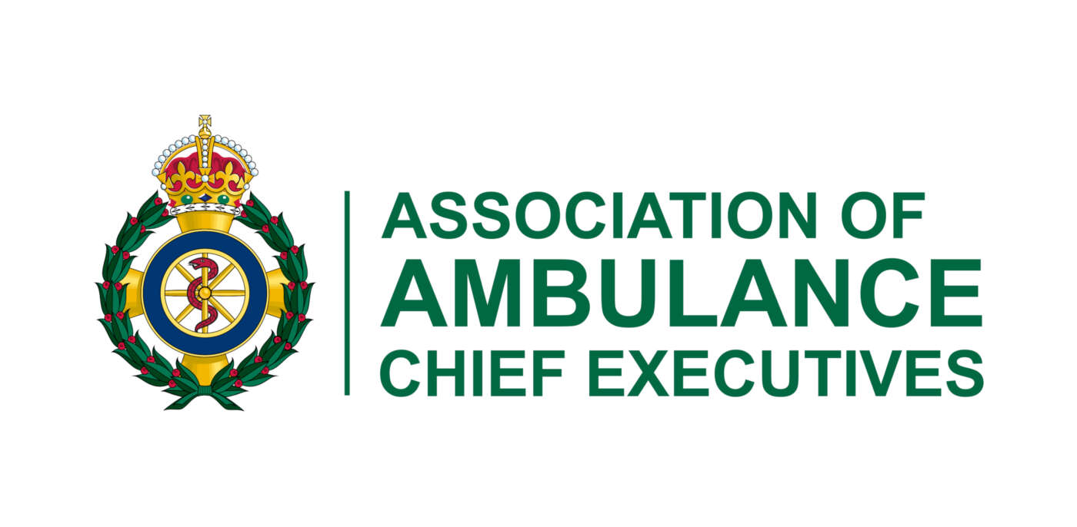

Abstract Submission Guide
Ambulance Leadership Forum
Conference 2027
ALF2027

To be held on
16th and 17th March 2027
at
The Crowne Plaza Hotel, Newcastle

Conference Theme: Collaboration
Every session will be categorised under one of three headings aligned to the AACE strategy: Reliable Providers, Respectful Employers, and Collaborative Partners.

Presentation Submission Guidelines

Closing Date: Friday 27th November 2026 at 17.00 (GMT)

Can I make a submission? The Association of Ambulance Chief Executives (AACE) invites abstract submissions to present at the Ambulance Leadership Forum on the 16/17th March 2027.
The organisers are seeking to select 5 papers to be delivered by the authors to the conference. The presentations need to relate to service delivery and/or leadership within ambulance services and/or the paramedic profession and should be evidence based, preferably based on applicants’ research activities. Successful applicants will also need to produce a poster about their work to be displayed throughout the event.

Do I have to pay? There is no fee for making a submission. If your submission is accepted for a presentation, then you will be required to attend the ALF2027 and cover your costs for doing so.

Schedule
Activity | Date
Abstract submission open | 21st September 2026
Deadline for abstract submission | 27th November 2026 at 17.00 (GMT)
Authors notified | Before 7th January 2027

Submitting an abstract

A. Important Information

- Submissions to present an oral presentation must be submitted online to https://app.onlinesurveys.jisc.ac.uk/s/herts/alf-abstract-submission-form-for-the-2027-conference
Or via the QR code



- Authors are not allowed to use tables.

B. Preparation of Your Submission

- An anonymised selection process will be used. No identifying features such as names of employer, education institutions or cities may be listed in the title or text of the submission. Do not include the names of authors in the abstract itself. The names of authors should be included on the submission template and will be removed before the submission is sent to the reviewing team.

- Presentations which have been presented to a substantially different audience, especially an international one, may still be submitted for consideration.

- The title should be as brief as possible but long enough to indicate clearly the nature of the study.

- Please use the template provided to structure your abstract. These areas will be used by the reviewers to judge your abstracts.
Only abstracts submitted through this portal and received before the deadline of 17.00 on the 27th November 2026 (UK time) will be taken into consideration by the reviewers.

For abstracts representing research projects, service evaluation, quality improvement projects, and audit, please use the following structure:
- Aims / Objectives
- Methods
- Results / Findings
- Conclusions / Recommendations / Implications for practice

When will I hear about the outcome of my submission?

We will write to everybody, by email, before the 7th January 2027 with details of the outcome of their submission. The outcome email will detail (for the 5 selected) what happens next, guidance on preparing your presentation and what will happen on the day.

We are only able to give information to the person who submitted the abstract.

Final Guidance

We will print your abstract from the version supplied by you. It will be printed exactly as submitted - this means that any errors or spelling mistakes will show. Please proofread your submission carefully.

We require a short biography and profile picture at the time of submission as we will publish successful abstracts online on the Ambulance Leadership Forum website.

Should you have any queries relating to your abstract then please do not hesitate to contact Julia.williams@rcop.co.uk

C. Presentation

Five Abstracts will be chosen for an oral presentation to be delivered at the ALF conference on either 16th or 17th March 2027. The audience number will be around 300 and will consist of senior leaders from across the UK ambulance services along with colleagues from the wider health economy, overseas guests and interested stakeholders.

Oral Presentation

Each presentation slot is to be 10 minutes in duration and no extra time is allowed. AACE will request draft slides/presentation material four weeks in advance of the conference to ensure compatibility with IT.

Poster Presentations

The five selected presenters will be asked to take any Q&As alongside their posters during conference breaks.

Judging & Award

Conference delegates will be asked to vote for their preferred paper / presentation from the five delivered. They will be guided to make judgement on a mixed criteria to include: impact, quality, originality and contribution to service delivery and provision of emergency and urgent care services.

A presentation to the winning author will be made on the day.
Appendix A – 3 pages in total

Abstract Submission Template

Submission Deadline – Friday 27th November 2026
First Name
Surname
Email Address
Organisation
Address 1
Address 2
Post Code
Contact No.

Please place a Y in the box and agree to the following statements:
I confirm that this abstract has been approved (as submitted) by all authors:
I have read and agree to follow the relevant abstract submission guidelines:
I understand that if my abstract is chosen for presentation that I am required to attend the conference:

Abstract Submission Template

Please populate the below table with a short biography that you wish to appear in marketing material and event programme.

Biography (maximum 200 words):

PLEASE ATTACH A PROFILE PICTURE (HIGH-RESOLUTION) THAT YOU CONSENT TO BE PUBLISHED

Abstract Submission Template

Please fill in the table below according to your type of submission. Additionally, we have added a specific section where you need to describe the specific relevance of your abstract to ambulance trusts and or the wider arena of unplanned, emergency and urgent care (50-word maximum, which is additional to the main abstract allowance of 400 words). This is mandatory and will be expected to be presented should your abstract be accepted. This can be in any capacity e.g. clinical, managerial, education etc.

Title:
Category (please select one that best fits your submission, aligned to the AACE strategy):
☐ Reliable Providers ☐ Respectful Employers ☐ Collaborative Partners

(Maximum 400 words)
Aims:
Methods:
Results/Findings:
Conclusion / Recommendations / Implications for Practice:

In addition, you are asked to write a maximum of 50 words explaining:
The relevance of your work to ambulance trusts and / or unplanned, emergency and urgent care

